Linear Regression

**Regression:** Regression makes relation between dependent and independent variable.

**Linear Regression:** Linear regression find the best fitting straight line with minimum sum of square error.

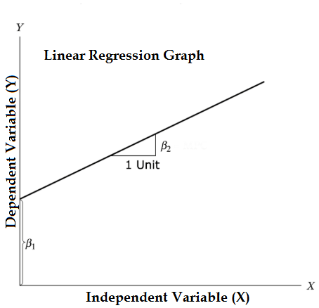

*There are2 types of Linear Regression

1.Simple Linear Regression

Example: y=mx+c

2.Multiple Linear Regression

Example: y=a0 + a1x1 + a2x2 + ... + anxn